Professional Identity – BY Design, Not Default
“Engaging in deeply gratifying work requires consistent, focused efforts to cultivate your instincts and skills, and make measured progress on your goals. This requires urgency and diligence.” Todd Henry
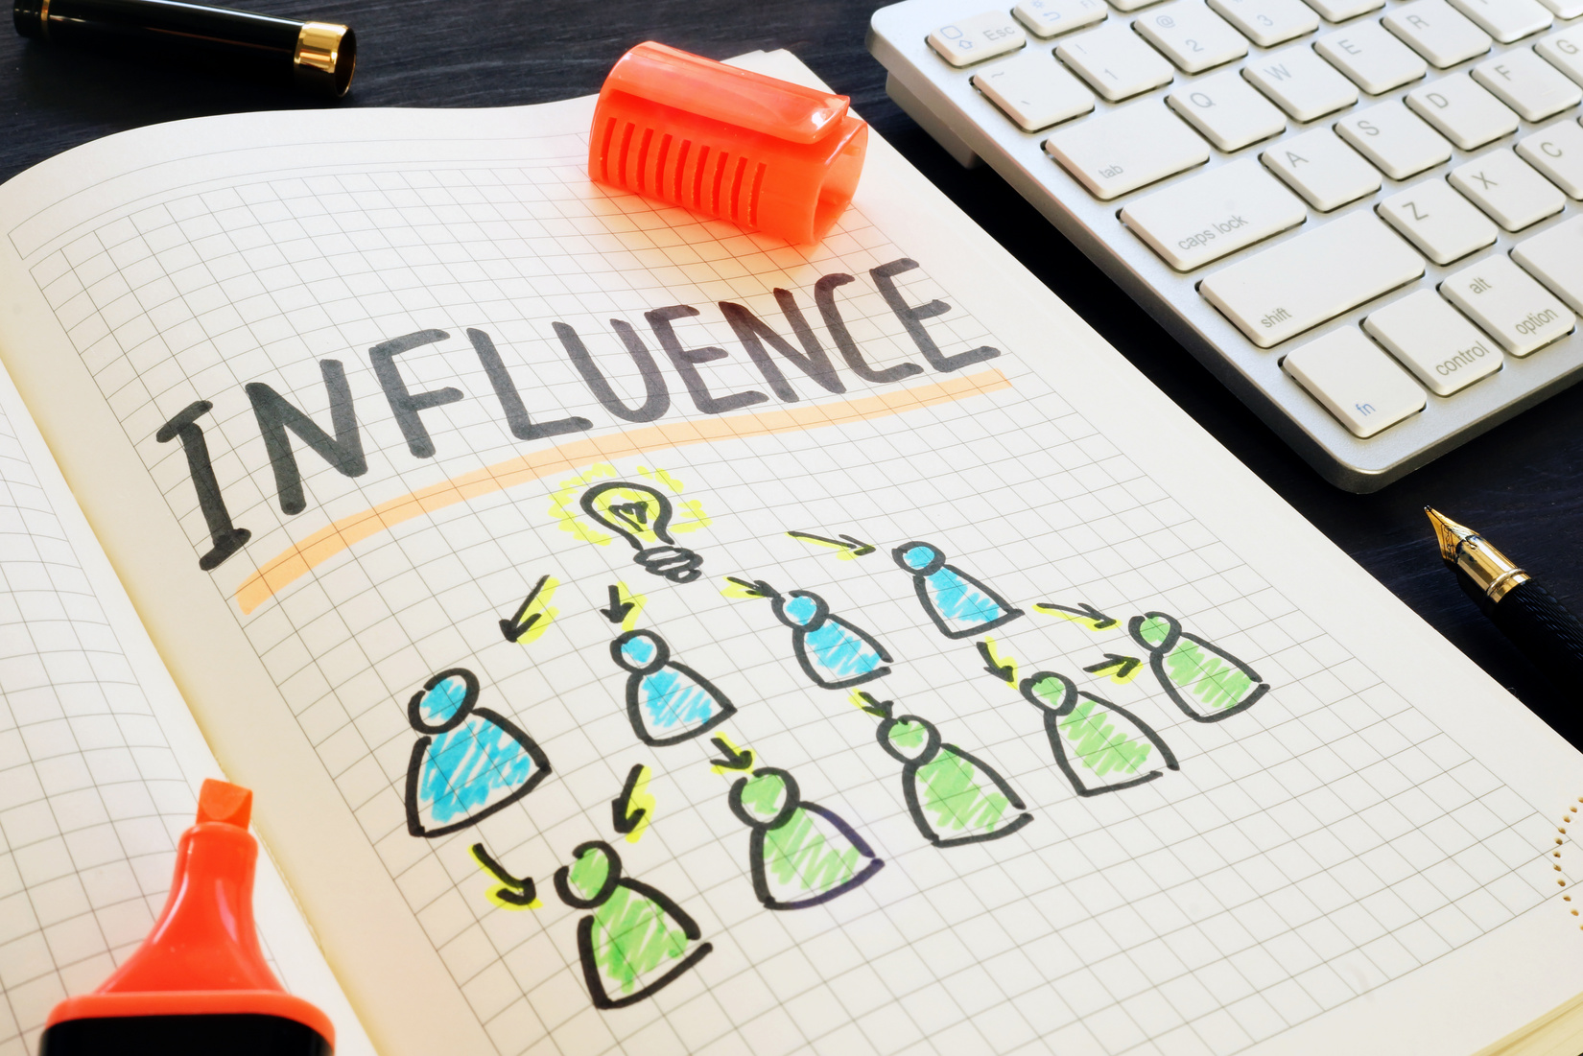
Individuals who develop a strong professional identity will design a life and career with greater impact and purpose.

Session objectives
- Engage in conversation about professional identity and its role in overall wellbeing.
- Provide activities and resources for exploration of professional identity.
- Facilitate participants’ design of a professional identity plan.

Professional Identity
Professional identity is based on social roles/group membership, as well as personal & character traits you display/others attribute to you (Ibarra, 1999).
“Professional identity is not a stable entity; it is complex, personal, and shaped by contextual factors” (Clarke, Hyde, & Drennan, 2013, p. 8)

Ibarra – Role Adaptation
I admire people who:
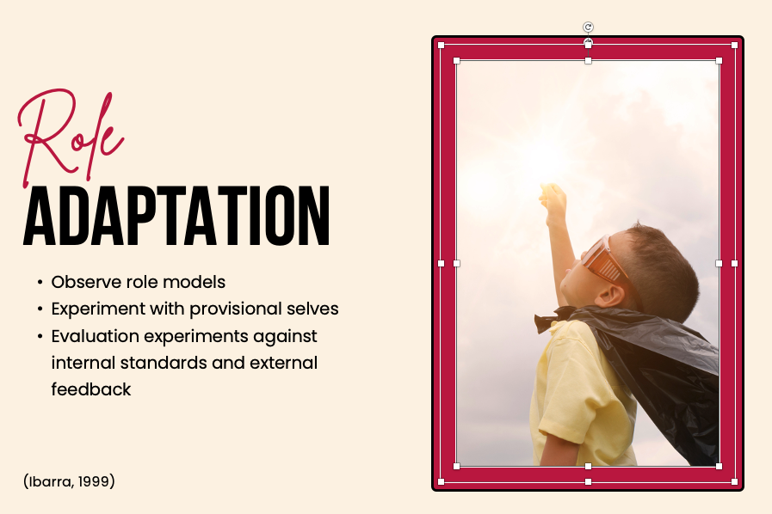

Erikson Identity Stages
Where do you feel you are in your current position/career?
Birth to 18 months Basic Trust vs. Mistrust Hope
18 months to 3 years Autonomy vs. Shame Will
3 to 5 years Initiative vs. Guilt Purpose
6 to 12 years Industry vs. Inferiority Competence
12 to 18 years Identity vs. Role Confusion Fidelity
18 to 40 years Intimacy and Solidarity vs. Isolation Love
40 to 65 years Generativity vs. Self-absorption or Stagnation Care
65+ years Integrity vs. Despair Wisdom

Professional identity = Personal brand
“Personal branding is about managing your name — even if you don’t own a business — in a world of misinformation, disinformation, and semi-permanent Google records. Going on a date? Chances are that your ‘blind’ date has Googled your name. Going to a job interview? Ditto.” Tim Ferriss

Personal brand
Values | Talents/Strengths

Institutional Values (See TTUHSC Values Based Culture in Appendix)

My brand __________________________________________________________________________

Design vs. Default
“It’s easy to get lost, and wake up many years later in a strange land asking yourself, ‘Who am I, how did I get here, and how do I get back?’” Todd Henry
A strong professional identity provides purpose and satisfaction. Without a strong identity, you may be acting in a mode of default.

Reflection on professional identity
Have you been focused on your values/purpose?
- Network
- Activities
- Image
“The only way to avoid getting off track or burned out is to be mindful and engage in consistent practices that keep you on the path you design.” Toddy Henry

Professional Identity Reflection (see Professional Identity Checklist in appendix)
Good | Needs Work | Missing
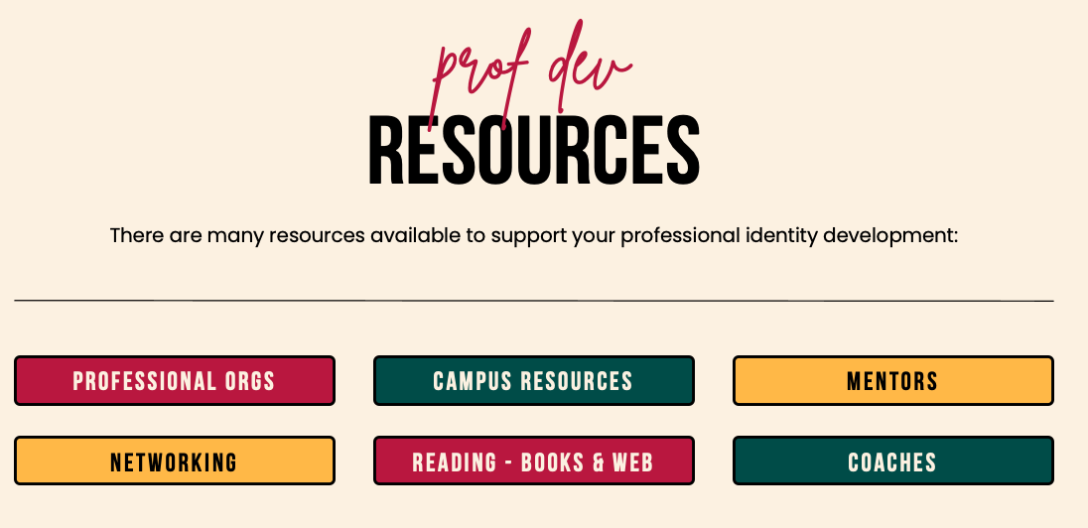
“Human resources are like natural resources; they're often buried deep. You have to go looking for them, they're not just lying around on the surface. You have to create the circumstances where they show themselves.”
Ken Robinson

Action Plan

Professional Identity Action Plan (see stretch activities in appendix)
“If you expect the battle to be insurmountable, you've met the enemy. It's you.” Khang Kijarro Nguyen

Action/Resources Needed

Within Six Months

Within One Year

Focus

Within Three Months

Within One Month

Accountability Measures
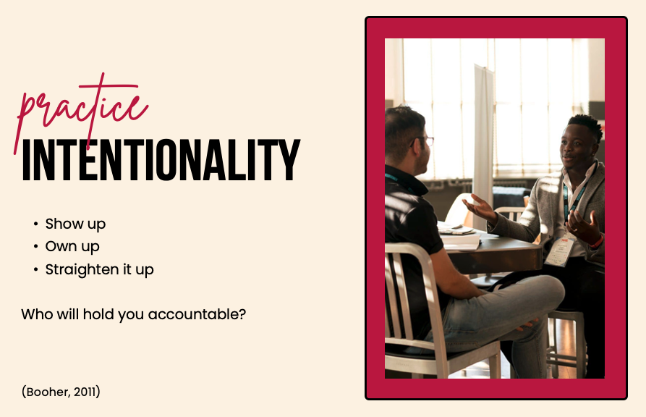
“Your body of work includes every task and project, every time you encourage someone else or contribute to a relationship, every time you make an effort to grow your skills or develop your mind, every time you go the extra mile even though you are exhausted.” Toddy Henry

Wrap Up
How can you and your colleagues/office think about the larger identity and work to challenge one another up/support each other?

References
Henry, T. (2013). Die empty: Unleash your best work every day. New York, NY: Penguin.
Ibarra, H. (1999). Provisional selves: Experimenting with image and identity in professional adaptation. Administrative Science Quarterly, 44(4), 764-791.
Thornton, H. (2013). Living and working by design, not by default. Organized for Life: Less Clutter. More Life. Retrieved from http://www.org4life.com/living-and-working-by-design-not-by-default/
Woo, H.R. (2013). Instrument construction and initial validation: Professional identity scale in counseling (PISC). (Doctoral dissertation). Retrieved from Iowa Research Online. http://ir.uiowa.edu/etd/2663

HSC Values Based Culture

One Team
Unite and include diverse perspectives to achieve our mission.
- Empower and energize one another to create positive growth
- Collaborate through open communication
- Hold ourselves and each other accountable by giving and accepting constructive feedback
- Foster a fun and healthy environment that encourages team spirit
- Recognize and celebrate contributions and achievements

Kindhearted
Exceed expectations with a kind heart, helping hands and a positive attitude.
- Assume good intentions
- Listen first to understand
- Treat all consistently with compassion, respect and an open mind
- Acknowledge each other with courtesy
- Respond rather than react

Integrity
Be honorable and trustworthy even when no one is looking.
- Be honest regardless of the outcome
- Make ethical choices in every situation
- Honor commitments
- Be transparent in your purpose, expectations and actions
- Protect and conserve institutional resources

Visionary
Nurture innovative ideas, bold explorations and a pioneering spirit.
- Promote an innovative environment that embraces appropriate risk
- Be resilient and confident when faced with challenges
- Inspire continuous curiosity
- Demonstrate and inspire commitment to life long learning and personal development

Beyond Service
Create and deliver positive defining moments.
- Anticipate the needs of each individual and respond with a generous heart
- Invest in the well-being, safety and success of all by going the extra mile
- Be solution-oriented, create the pathway to a win-win resolution
- Deliver excellence in everything we do

Professional Identity Checklist for Advising Professionals
This checklist is designed to assess your current thinking/behavior as it relates to the advising profession and your professional identity. This list is not exclusive and is intended solely to stimulate self-reflection.

Knowledge of the Profession
- I know the origins of the advising profession.
- I am knowledgeable about the origins of the advising profession and the important events and milestones (e.g., establishment of NACADA) in advising history.
- I am knowledgeable about standards and guidelines that relate to advising (e.g., CAS Standards for Academic Advising).
- I am familiar with professional advising associations (e.g., NACADA: The Global Academic Advising Association) and their roles and accomplishments in the profession.
- I am knowledgeable of professional advising journals (e.g., NACADA Journal, AAT: Academic Advising Today, journal(s) relevant to my specialty area) and their contents’ foci and purposes in the profession.
- I am able to distinguish similarities and differences between my profession and other higher education professions.
- I am familiar with laws and regulations related to the advising profession.
- I am familiar with theories related to advising (e.g., student development and learning theories).
- I am knowledgeable about the core values of academic advising.

Professional Roles & Expertise
- I value various professional roles (e.g., advisor, administrator, educator, consultant, and advocate) that an advising professional can hold.
- I recognize an advising professional’s roles and duties vary depending on settings, diverse populations served, and the person’s specialty.
- I believe an advising professional should value the importance of advocacy for the populations that the person serves.
- I believe an advising professional should value the importance of advocacy for the profession that the person belongs to.
- I have reflected on and created my own advising philosophy.
- I have completed professional training and standard education to perform my duties in my roles.
- I have professional knowledge and practical skills required to successfully perform my roles.
- I am familiar with which resources to refer to when I need professional help.
- I consistently self-evaluate and self-reflect my effectives and performances in my chosen field.

Professional Attitude
- My profession has a well-established theoretical body of knowledge.
- My profession provides unique and valuable services to society.
- I value the advancement and the future of my profession.
- I recommend my profession to those who are searching for a new career related to helping professions.
- I am comfortable having discussions about the role differences between advising and other higher education professions (e.g., counseling, teaching, etc.).
- My personality and beliefs are well matched with the characteristics and values of my profession.
- I am satisfied with my work and professional roles
- I have a solid work-life balance and feel congruent.
- As an advising professional, I share my positive feelings (e.g., satisfaction) when working with people in other fields.

Engagement Behaviors
- I have memberships of professional advising associations (e.g., national, state-wide, and/or regional).
- I actively engage in professional advising associations by participating in conferences and workshops every year.
- I have contributed to expanding my knowledge base of the profession by participating in advising research (e.g., by being interviewed, taking surveys).
- I have conducted advising research.
- I have published research findings in my field.
- I follow up with theoretical, practical, and technical advancement in my profession by keeping up with literature (e.g., professional advising journals, books) in the field.
- I engage in or seek opportunities to serve in non-required leadership positions (e.g., advising association, committee work, etc.).
- I educate the community and public about my profession.
- I advocate for my profession by participating in activities associated with legislation, law, and policy on advising on behalf of the profession.

Professional Interaction
- I seek feedback/consultation from professional peers as a form of professional development.
- I regularly communicate with a mentor who is interested in my professional development
- I regularly communicate with a mentee who is interested in his/her professional development.
- I keep in contact with advising professionals through training and/or professional involvement in advising associations.
- I participate in ongoing discussions with advising professionals about identity and the vision of my profession.

Professional Identity Checklist for Advisors - Erin Justyna, September 2016 - Adapted from: Woo, H.R. (2013). Instrument construction and initial validation: Professional identity scale in counseling (PISC). (Doctoral dissertation)

Stretch Activities
- Request stretch assignments from your supervisor or colleagues.
- Write a personal mission or values statement.
- Obtain mentors inside and outside department.
- Conduct reverse mentoring to learn/teach technology concepts.
- Consider podcasts, blogs, and other e-learning events such as webinars.
- Take a speaking skills class complete with videotaping.
- Read a book related to development or your profession.
- Observe a leader and identify what them a good leader.
- Complete self-analysis instruments such as the MBTI or communication styles instruments.
- Write a white paper about a topic important to the organization.
- Listen to TED talks; create a list of the best and form discussion groups around them.
- Ask to spend a day shadowing someone you respect.
- Create a personal portfolio and/or maintain a professional journal.
- Develop a system of self-evaluation with feedback that is real.
- Read articles about pressing issues and send out to colleagues/ Conduct an article exchange.
- Leverage online learning modules/short courses.
- Benchmark another campus in a similar market to imagine future needs and requirements.
- Participate in on campus training and development events (e.g., departmental seminars/HR Webinars).
- Register for degree or certification classes.
- Present at a campus event/give training on a topic of which you are an expert.
- Participate in a Global Health lecture or film screening.
- Attend a graduate student’s master’s or PhD thesis defense.
- Initiate a book club, everyone reading a different book on the same topic and discussing.
- Hold networking sessions once a month; could be for coffee or after work.
- Hold lunch and learn events.
- Participate in intern recruitment, job fairs, and college visits.
- Engage in cross-training.
- Join a professional association.
- Attend local, regional, national, and international meetings, conferences and workshops sponsored by professional organizations.
- Present papers at conferences and workshops.
- Serve as an officer, board member, or committee member of a professional organization.
- Coordinate events sponsored by a professional organization.
- Join a board or volunteer for a local community agency.
Stretch activities adapted from: http://www.ebbweb.com/wp-content/uploads/2016/09/1-Personal-Improvement.pdf, https://hr.buffalostate.edu/professional-development-examples, and https://www1.villanova.edu/villanova/engineering/undergrad/professionaldevelopment/profDev.html

